# Problem 3 – Course Planner

**Working with Remote Data**

For the solution of some of the following tasks, you will need to use an up-to-date version of the **local REST service** provided in the lesson’s resources archive. You can [read the documentation here](https://github.com/softuni-practice-server/softuni-practice-server).

**Environment Specifics**

Please be aware that every JS environment may **behave differently** when executing code. Certain things that work in the browser are not supported in **Node.js**, which is the environment used by **Judge**.

The following actions are **NOT** supported:

* **.forEach()** with **NodeList** (returned by **querySelector()** and **querySelectorAll()**)
* **.forEach()** with **HTMLCollection** (returned by **getElementsByClassName()** and **element.children**)
* using the **spread-operator** (**...**) to convert a **NodeList** into an array
* **append()** (use only **appendChild()**)
* **prepend()**
* **replaceWith()**
* **replaceAll()**
* **closest()**
* **replaceChildren()**

If you want to perform these operations, you may use **Array.from()** to first convert the collection into an array.

## Requirements

Write a JS program that can load, create, remove and edit a list of courses. You will be given an HTML template to which you must bind the needed functionality.

First, you need to install all dependencies using the npm install command

Then, you can start the front-end application with the npm start command

You also must start the ***server.js*** file in the ***server*** folder using the node server.js command in another console **(BOTH THE CLIENT AND THE SERVER MUST RUN AT THE SAME TIME)**.

At any point, you can open up another console and run npm test to test the **current state** of your application. It’s preferable for **all of your tests to pass locally** before you submit to the Judge platform, like this:

Картина, която съдържа текст

Описанието е генерирано автоматично

## Endpoints

* [**http://localhost:3030/jsonstore/tasks/**](http://localhost:3030/jsonstore/tasks/)
* [**http://localhost:3030/jsonstore/tasks/**](http://localhost:3030/jsonstore/tasks/)**:id**

## Load Courses

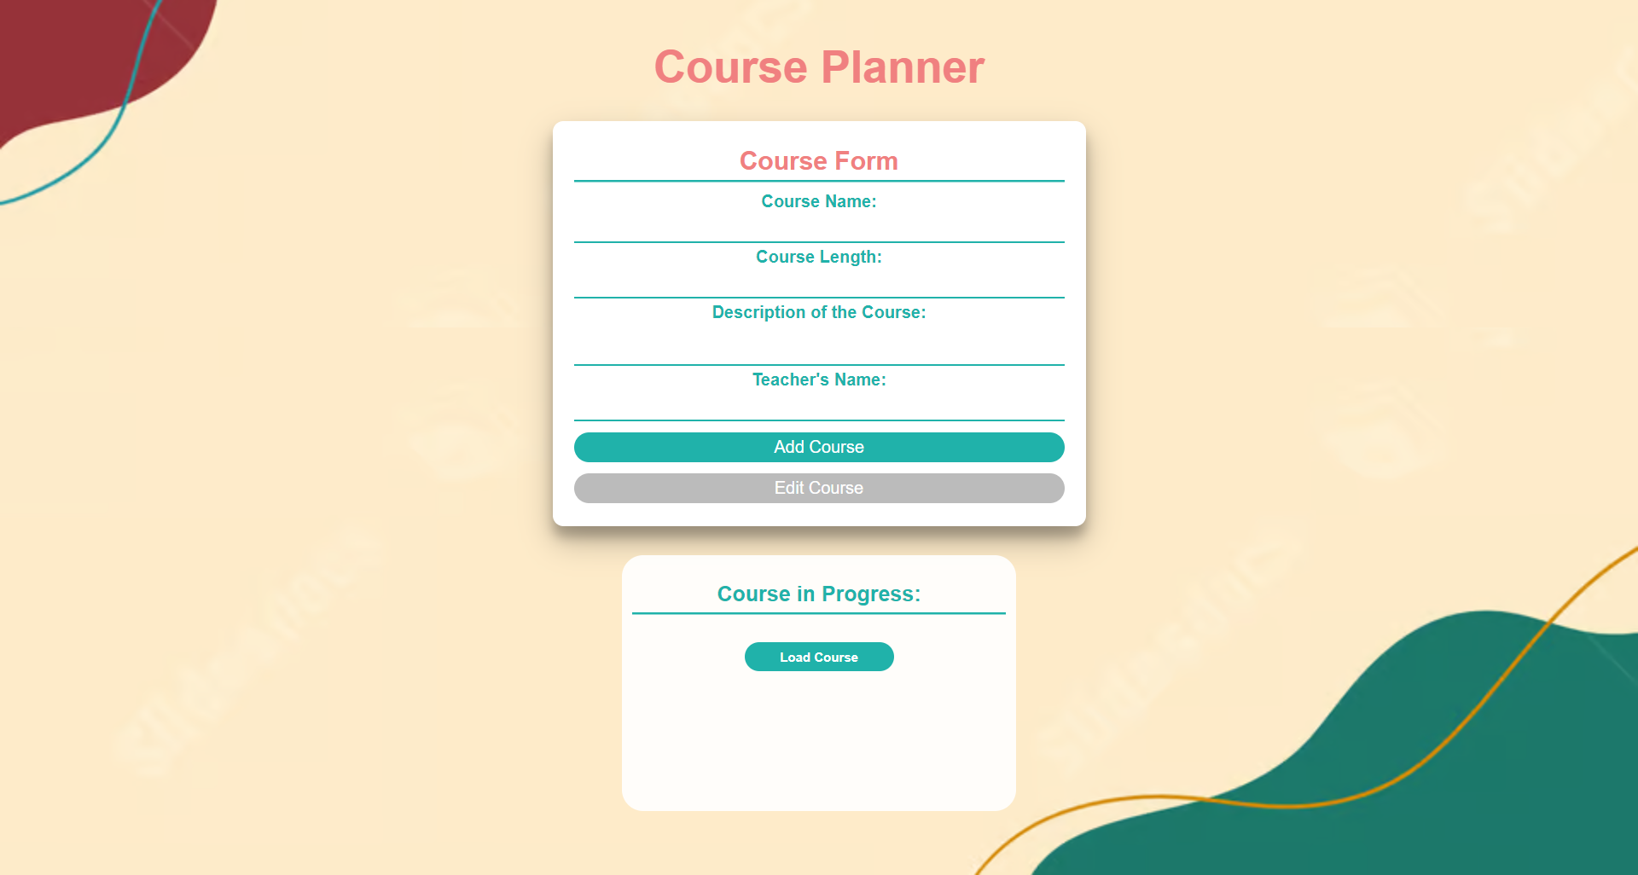

Clicking the **[Load Courses]** button should send a **GET** request to the server to fetch **all courses** from your local database. You must add each task to the<div>with **id="list".**

Each course has the following **HTML** **structure**:

Картина, която съдържа текст

Описанието е генерирано автоматично

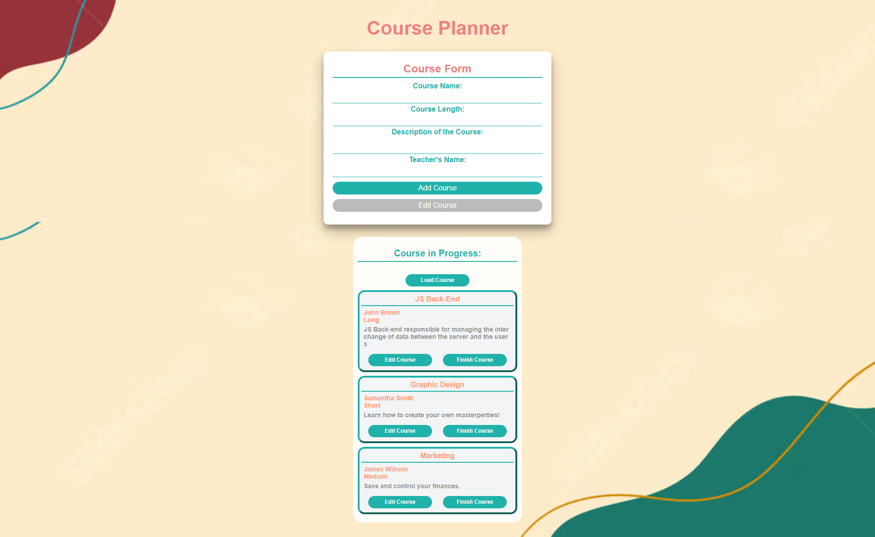

## Add а Course

Clicking the **[Add Course]** button should send a **POST** request to the server, creating a new course with the **title**, **type** (“Long”, “Medium”, or “Short”), **description, , and the teacher's name** from the input values. After a successful creation, you should send another **GET** request to fetch all the courses, including the **newly added one** into the **Course Progress** column. You should also **clear all the input fields** after the creation!

Картина, която съдържа диаграма

Описанието е генерирано автоматично

## Edit a Course

Clicking the **[Edit Course]** button on a record should remove the record from the DOM structure and the information about the task should be populated into the input fields above. The **[Edit** **Course]** button in the form should be activated and the **[Add Course]** one should be deactivated.

After clicking the [**Edit Course]** button in the form, you should send a **PUT** request to the server to **modify the title, type, description, and the teacher’s name** of the changed item. After the successful request, you should **fetch the items again** and see that the changes have been made. After that, the **[Edit** **Course]** button should be deactivated and the **[Add Course]** one should be activated.

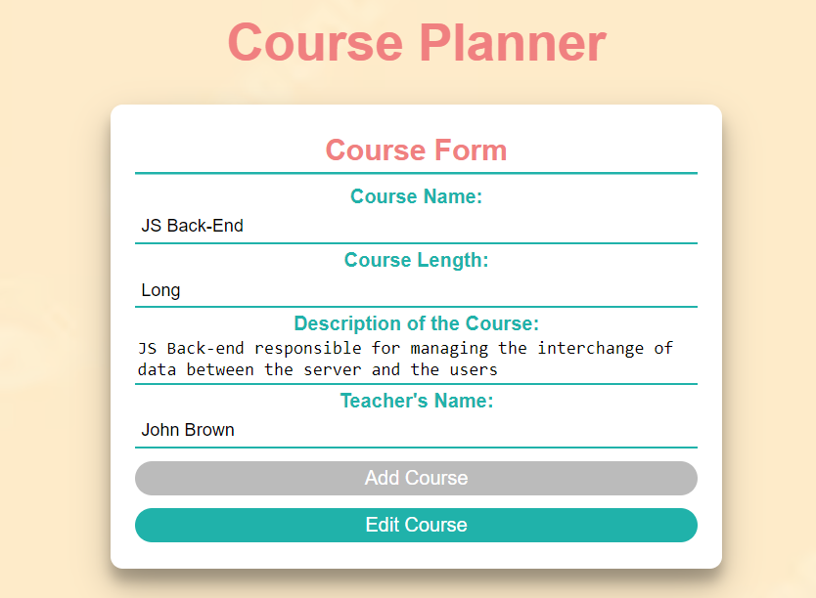

## Finish a Course

Clicking the **[Finish Course]** button should send a **DELETE** request to the server and remove the item from your local database. After you've removed it successfully, **fetch** the items **again**.

## Submitting Your Solution

Select the content of your working folder (the given resources). Exclude the ***node_modules*** & ***tests*** folders. Archive the rest into a **ZIP** file and upload the archive to Judge.

Картина, която съдържа текст

Описанието е генерирано автоматично

Картина, която съдържа текст

Описанието е генерирано автоматично